Create a shell script emailcleaner.sh that processes emails.txt.
• Extract all valid email addresses and store them in valid.txt
• Extract invalid email addresses and store them in invalid.txt
• Remove duplicate entries from valid.txtValid email format:<letters_and_digits>@<letters>.comUse grep, sort, uniq, and redirection
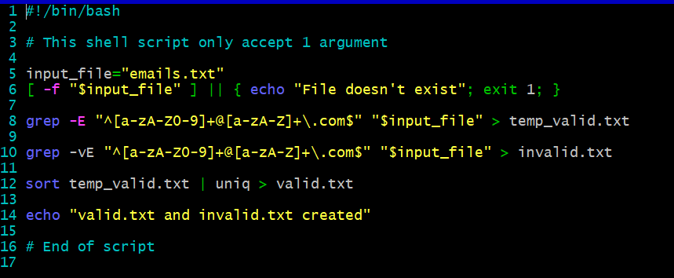
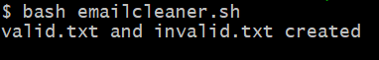
Valid.txt
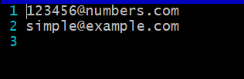
Invalid.txt
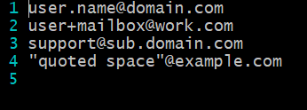
Explanation: So above script is a really good email checker which check with some constrains provided. It sort, check for uniquiness using uniq command sort command and main use of grep to match the desire form. I am using redirection > command to create both required files which contain sorted valid and invalid email addresses.

